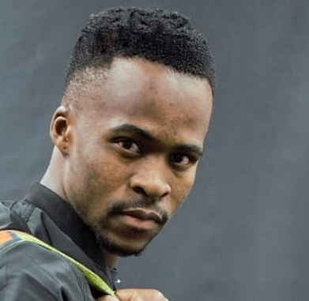Artistic profile

**Name:** Mfundo “Mash”

**Surname** : Shabangu

**ID number** : 9803026291086

**Size :** Medium

**Height :** 1,78m

**Skin color :** light brown

**Eyes :** brown

**Artistic background :** South African State Theatre

**Talents :** Director , Musical Theatre

**Extra Talents** : precisionist and voice over talent

**Hobbies** : reading and writing

**Languages :***English,Afrikaans,Ndebele,Zulu,Pedi,Setswana,Sotho & Xhosa*

|  |  |  |  |  |  |  |
| --- | --- | --- | --- | --- | --- | --- |
| **PRODUCTIONS** | **NAME OF PRODUCTION** | **YEAR** | **ROLE** | **DIRECTOR/ COMPANY** | **AWARDS** |  |
| **Theatre** |  |  |  |  |  |  |
|  | **Birth** | **2015**  **Pop Art, The Platform theatre)** | **Joe-Malome** | **Joseph Komani** |  |  |
|  | **Foot joy** | **2017 (State theatre)** | **Snake (lead actor)** | **Usuthu** |  |  |
|  | **Magrosi** | **2017 (state theatre)** | **Back up singer** | **Godfrey Thobejan** |  |  |
|  | **Jabulani and the lion** | **2017 (state theatre)** | **Baboon(lead actor)** | **Kenny mmekwa** |  |  |
|  | **Beating the ground** | **2017(State theatre)** | **Uncle(supporting)** | **Kenny Mmekwa** |  |  |
|  | Sugar daddy | 2017(pretoria fire station) | Mike(lead actor) | Simon makama |  |  |
|  | Anguish | 2017(state theatre) | patrike(Lead actor) | Sbusiso kwinana |  |  |
|  | Much ado about nothing | 2017(state theatre) | Pedro lead) | &Simon makama |  |  |
|  |  |  |  |  |  |  |
|  | Lover of his people(Solomon Platjie Production) | 2018(State theatre) | Numerous characters(supporting) | Lover of his people production &Joseph komani |  |  |
|  |  |  |  |  |  |  |
|  | African dustbin | 2019(Mariam makeba theatre) | Mthengisi gwala(lead) | Thulane shange |  |  |
|  | My children My Africa | 2019(breytenbech theatre) | Thami (lead) | Gift Mathibedi |  |  |
|  | Dreaming of light | 2019(ditsong culture history museum) | Thaiba(lead) | Thulane Shange |  |  |
|  | Sopiatown | 2019 (Secunda theatre) | Mingus (lead) | Thulane Shange |  |  |
|  | The light house keppers wife | 2019 (Secunda theatre) | Barney (Support) | Thulane Shange |  |  |
| TELEVISION | | | | | | |

|  |  |  |  |  |  |
| --- | --- | --- | --- | --- | --- |
|  | | | | | |
| Short films |  |  |  |  |  |
|  | Love colours | 2019(duma pictures) | Hungani (lead) | Mr.pompie |  |
|  | Rirhandzu | 2020(edu-tainment) | Sam (lead) | Mduduzi Nhlapho |  |
|  | | | | | |
| Documentary | Tsoga Africa fashion show | 2019(Aforika cultural consultancy) | Production coordinator and director |  |  |
|  | Ditsong culture museum | 2019(ukukhanya edu-tainment) | Performance director |  |  |
|  |  |  |  |  |  |
| Commercials | SA Survior | 2019 | Support role |  |  |
|  | Lifetime channel promotion | 2019 (Gold Island Studios) | Boyfriend (lead) |  |  |